There are at least 3 ways to flash and debug the MCU, STM32 JTAG/SWD and VCP. The connection STDC14 was selected for convenience of compatibility with the STLINK-V3SET and any STM32 ARM MCU. The following is a capture of the pinout of the standardized connector:

(Taken from UM2448 STLINKV3 Set Documentation)

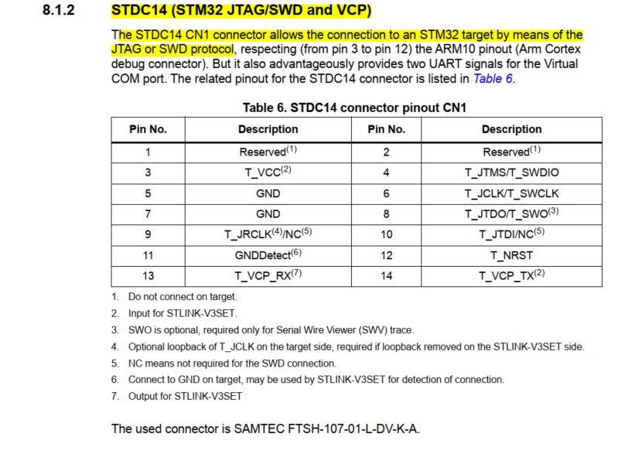

# General physical constraints for the PCB

Available Size from the EVL-BRD-LAN9252-SPI

56mm X